**STOCK PORTFOLIO OPTIMIZER**

**DATE:**6TH JUNE 2024

**SUBMITTED BY:** KOTTU JOHNSON AND 22KQ1A0752

**DETAILS OF PROJECT:** I’M IMPLEMENTING THIS PROJECT BY USING PYTHON PROGRAMMING LANGUAGE.

**CODE**

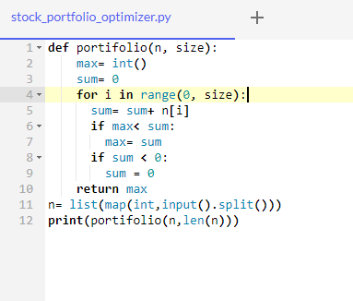

**INPUT AND OUTPUT**

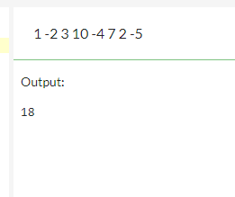

**EXPLAINATION:** This Python program defines a function called portfolio which is a list of integers representing the gains or losses from investments, and size, which is the number of elements in the list n.

Max**-** is the element used to store the maximum value.

Sum **–** is the element used to store the encounted value.

N **–**iterates through each element using loop

Sumvariable updates the variable by adding the current element of n to it.If the sum is grater than the current maximum it updates max to the value of sum.It checks wheather the value is negative it resets the sum value to zero.Else it update the value.After iterating the elements in N it returns the maximum sum.and then it calls the portfolio function with the input list and its length (len(n)).The maximum sum returned to the portfolio function and then it prints the maximum.

**CONCLUSION:** FINALLY I HAVE GOT THE DESIRED OUTPUT **18**